**Router upgrade procedure for GBLN**

Pre-Checks: -

1.Take Backup of Config File from both router CSR A and CSR B.

#wr mem

#more system running-config.

2.Take Snapshot for CSR A and CSR B from AWS Console

**CISCO-CSR-A-BYOL**

instance_id:-i-04fb3fe451b4d6149

volume_id:-vol-0a5eee0ffdd5f2af1

**CISCO-CSR-B-BYOL**

instance_id:-i-0ab4814f362ec90f6

volume_id:-vol-0ad898e9c9e9c7f92

3.Capture below output from router by session logging.

#show version

#show license status

#show license summary

#show ip interface brief

#show bgp summary

#show bootvar

4.Check bootflash memory and available space.

#dir bootflash:

5.Before Performing activity .

#We should have console access and local credentials to login.

#Make sure you have console and enable password,

#Raise JIT request to get console access. You can contact [vivek-1.mishra@novartis.com](mailto:vivek-1.mishra@novartis.com)

**Implementation Plan**

Step1) – Upgrade firmware on Secondary RouterB to firmware version 17.3.4a

Step1.1) Break the BGP Neighborship from Router B, So that Router A should take Traffic and we can perform upgrade on Router B

nvs-gbln-puc-aws-rt02(config)#**router bgp 64667**

**neighbor 10.185.249.13**

**neighbor 169.254.20.101**

**neighbor 169.254.20.157**

After breaking BGP neighborship,

Step 2) Validate Primary Traffic on Router A

C:/>**tracert 10.185.239.118** (DMZ IP) from jumpbox to verify that currently the traffic is going via Router A(Primary)

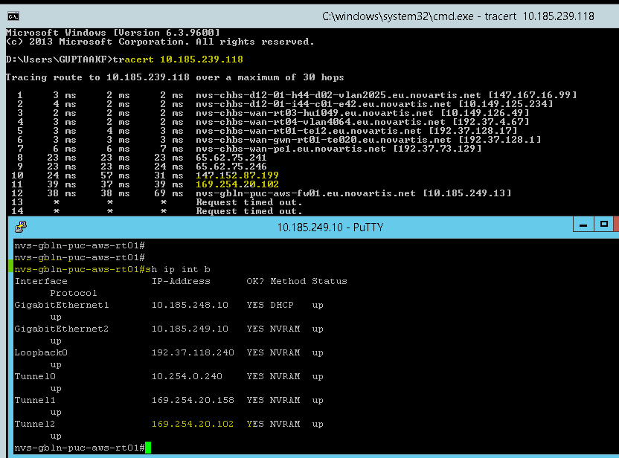

Step3) – Upgrade firmware on Secondary RouterB to firmware version 17.3.4a

3.1 Change the boot variable on router.

Config#**boot system flash bootflash:/csr1000v-universalk9.17.03.04a.SPA.bin**

Config# **wr mem**

3.2 Validate boot variables

Config#**show bootvar**

3.3 Validate Config register in show version – if it set to 0X2102, we are good and no need to change the config register else please update the config register as below.

Router(config)# **config-register 0x2102**

3.4 Reload the router –

Router# **reload**

3.5 Verify the new version –

Router# **show version**

Step 4) Once upgrade done on Router B, Bring BGP neighborship UP and validate traffic is going via Router B.

nvs-gbln-puc-aws-rt0(config)#**router bgp 64667**

**no neighbor 10.185.249.13**

**no neighbor 169.254.20.101**

**no neighbor 169.254.20.157**

Step5) Once Upgrade done on Router B. Break the BGP Neighborship from Router A, So that Router B should take Traffic and we can perform upgrade on RouterA

nvs-gbln-puc-aws-rt01(config)#**router bgp 64667**

**neighbor 10.185.249.13**

**neighbor 169.254.20.101**

**neighbor 169.254.20.157**

After breaking BGP neighborship,

Step6) – Upgrade firmware on Primary RouterA to firmware version 17.3.4a

6.1 Change the boot variable on router.

Config#**boot system flash bootflash:/csr1000v-universalk9.17.03.04a.SPA.bin**

6.2 Validate boot variables

config#**show bootvar**

6.3 Validate Config register in show version – if it set to 0X2102, we are good and no need to change the config register else please update the config register as below.

Router(config)# **config-register 0x2102**

6.4 Save the configuration –

Router# **write memory**

6.5 Reload the router –

Router# **reload**

6.6 Verify the new version –

Router# **show version**

6.7 Once upgrade done on Router A, Bring BGP neighborship UP and validate traffic is going via Router A.

nvs-gbln-puc-aws-rt0(config)#**router bgp 64667**

**no neighbor 10.185.249.13**

**no neighbor 169.254.20.101**

**no neighbor 169.254.20.157**



**Post-checks**

- Capture below output from both the routers and attach on IT Change Ticket.

#show version

#show license status

#show license summary

#show ip interface brief

#show bgp summary

#show bootvar

<https://www.cisco.com/c/en/us/td/docs/routers/csr1000/software/configuration/b_CSR1000v_Configuration_Guide/b_CSR1000v_Configuration_Guide_chapter_01001.html>

Note: -After any reboot, if you are not able to SSH router, please check SSH Enabled or not.

config#**Show ip ssh**

To Enabled SSH on router.

nvs-gbln-puc-aws-rt01 (config)#**ip ssh version 2**

nvs-gbln-puc-aws-rt01 (config)#**crypto key generate rsa usage-keys label ssh-key**

nvs-gbln-puc-aws-rt01 (config)#do wr mem

Now Try to SSH Router